Data Warehousing & Business Intelligence (IT)

3rd Year,1st Semester

**Assignment 1**

Submitted to

Sri Lanka Institute of Information Technology

IT20100698

BRITTO T.A

Weekday Batch

**STEP 01: Data set selection**

This dataset is an extension of MovieLens10M dataset, published by GroupLeans research group. It connects the movies in the MovieLens dataset to their web pages on the Internet Movie Database (IMDb) and the Rotten Tomatoes movie review systems. Only those users with both rating and tagging information were maintained from the original dataset. The dataset is released in the framework of the 2nd International Workshop on Information Heterogeneity and Fusion in Recommender Systems (HetRec 2011).

According to the assignment principles, the data set was started with enough data.

In my data set which I have selected there are transactional data, and it has data of more than a year.

I can receive two sources of data from the data set that I selected (CSV and a text file). And the data set is sufficient to build a data warehouse. I was able to perform ETL functions with this data set.

And I can correctly identify hierarchies, dimensions, and aggregates in this data collection. I also realized that with this data collection, I will be capable of creating correct reports.

So, I selected this MovieLens + IMDb/Rotten Tomatoes details data set for my assignment.

Data Set Link:

<https://grouplens.org/datasets/hetrec-2011/>

The ER Diagram of the Data set

**STEP 02: Preparation of Data Sources**

There were ten csv files available in the data set. They are movie_actors.csv, movie_countries.csv, movie_directors.csv, movie_genres.csv, movie_locations.csv, movie_tags.csv, movies.csv, tags.csv, user_ratedmovies.csv and user_taggedmovies.csv. Among these csv files movie_countries.csv, movie_directors.csv, movie_tags.csv, tags.csv and user_taggedmovies.csv were not taken to create tables.

I created separate two tables for my source dataset by dividing movies.csv. They are movies table and rottenTomatoesRating table. And I decided to convert movies data csv into text file format as movies.txt. I renamed rottenTomatoesRating table as rotten_tomatoes.csv.

|  |  |  |
| --- | --- | --- |
| **Data Source Name** | **Data Source Type** | **Description** |
| Movies | TEXT | This file contains basic information about the movies of the database |
| Rotten Tomatoes | CSV | This file contains information about the Rotten Tomatoes ratings of the movies |
| Movie Locations | CSV | This file contains filming locations of the movies |
| Movie Genres | CSV | This file contains the genres of the movies. |
| User Rated Movies | CSV | This file contains the information about how users have rated the movies, and the date that a specific rating has done |
| Movie Actors | CSV | This file contains the main actors and actresses of the movies.  A ranking is given to the actors of each movie according to the order in which they appear on the movie IMDb cast web page. |

Then I imported those csv files into my newly created HetRecMovies_SourceDB. After I imported my csv files into sourceDB, I created Data warehouse named HetRecMovies_DW and created my dimension tables and fact tables inside the data warehouse.

The tables which I have imported to my database source is shown below.

**movie_actors.csv movie_genres.csv**

**movie_locations.csv** **user_rated_movies.csv**

**movies.csv**

created separate two tables for my source dataset by dividing main movies.csv

**rotten_tomatoes.csv** **movies.csv**

The movie details were taken as a text file, and I used it as another source type.

**movies.csv movies.txt**

I have loaded movie_actors.csv, movie_genres.csv, movie_locations.csv, user_rated_movies.csv, rotten_tomatoes.csv files to the DB called HetRecMovies_SourceDB.

Data Sources Data Types

**STEP 03: SOULUTION ARCHITECTURE**

Architectural diagram

The data warehouse is the core of the BI system. A data warehouse is a database built for the purpose of data analysis and reporting. This purpose changes the design of this database as well. This architecture shows the high-level BI solution to the warehouse.

**STEP 04: Data Warehouse design and development**

**Assumptions**

I have taken **DimMovieActors as slowly changing dimension**, Actor Ranking can change time to time, and we need to keep track of their historical data.

For my data set the schema is a snowflake schema. In my data set there are 4-dimension tables, date dimension and a fact table. The slowly changing dimension is Movie Actors table.

I have implemented data warehouse tables in the SQL server and the tables that I have created are

shown below.

**Data Warehouse Date Types**

Before creating the FactUserRatedMovies fact table and other dimensions, start by creating the Date

dimension. For that I used the code in the file “DateMaster.sql” file.

**FactUserRatedMovies**  **DimMovieGenres**

**DimRottenTomatoes**

**DimMovieActors DimMovies**

**DimDate**

**STEP 05: ETL development**

First using the SQL Server Integration Services Software, I have extracted all the data from the tables which were in the HetRecMovies_SourceDB and Extract movies.txt to separate staging DB called HetRecMovies _Staging as shown in the below.

**HetRecMovies_Staging**

**Extract Movie Actors Data to Staging**

Used OLE DB Source as dbo. movie_actors data table in HetRecMovies_SourceDB.OLE DB Destination for create new table MovieActors_Staging in the HetRecMovies _Staging database.

Used to execute SQL Task SSIS tool truncate table for SQL command as truncate table [HetRecMovies_Staging]. [dbo]. [MovieActors_Staging] in HetRecMovies_Staging database.

**Extract Movie Locations Data to Staging**

Used OLE DB Source as dbo. movie_locations data table in HetRecMovies_SourceDB.OLE DB Destination for create new table MovieLocations_Staging in the HetRecMovies _Staging database.

Used to execute SQL Task SSIS tool truncate table for SQL command as truncate table [HetRecMovies_Staging]. [dbo]. [MovieLocations_Staging] in HetRecMovies_Staging database.

**Extract Movie Genres Data to Staging**

Used OLE DB Source as dbo. movie_genres data table in HetRecMovies_SourceDB.OLE DB Destination for create new table MovieGenres_Staging in the HetRecMovies _Staging database.

Used to execute SQL Task SSIS tool truncate table for SQL command as truncate table [HetRecMovies_Staging]. [dbo]. [MovieGenres_Staging]in HetRecMovies_Staging database.

**Extract RottenTomatoesRating Data to Staging**

Used OLE DB Source as dbo. rotten_tomatoes data table in HetRecMovies_SourceDB.OLE DB Destination for create new table RottenTomatoesRatings_Staging in the HetRecMovies _Staging database.

Used to execute SQL Task SSIS tool truncate table for SQL command as truncate table [HetRecMovies_Staging]. [dbo].[RottenTomatoesRatings_Staging] in HetRecMovies_Staging database.

**Extract User Rated Movies Data to Staging**

Used OLE DB Source as dbo. User_rated_movies data table in HetRecMovies_SourceDB.OLE DB Destination for create new table UserRatedMovies_Staging in the HetRecMovies _Staging database.

Used to execute SQL Task SSIS tool truncate table for SQL command as truncate table [HetRecMovies_Staging]. [dbo]. [UserRatedMovies_Staging] in HetRecMovies_Staging

database.

**Extract Movies Data to Staging**

Used Flat file Source SSIS tool, to extract movies.txt data.

Used OLE DO Destination SSIS tool to create new table as movies.txt load next file data to HetRecMovies_Staging database.

Used to execute SQL Task SSIS tool truncate table for SQL command as truncate table [HetRecMovies_Staging]. [dbo]. [UserRatedMovies_Staging] in HetRecMovies_Staging

database.

**Data Profiling**

I used the staging table data to analyze how the data looks like to determine what type of transformations I need to perform on the data.

**

When double click the Data Profiling task and click on Open Profile Viewer to view the analyzed data.

**Data Transformation**

**Transform and Load Rotten Tomatoes Data**

I created Rotten Tomatoes data Transformation by below mentioned steps.

* + - * Created new package called HetRecMovies_Load_DW.dtsx.
      * Then Dragged and dropped a Data Flow Task, renamed it as Transform and LoadRotten Tomatoes Dataand go the Data Flow tab.
      * Dragged and dropped OLE DB Source, renamed as Extract from RottenTomatoes Staging and configure it to access the Rotten Tomatoes Staging table**.**
      * After that I dragged and dropped OLE DB Command rotten tomatoes and connect the OLE DB sourceIn the OLE DB Command, I set the configurations as below.

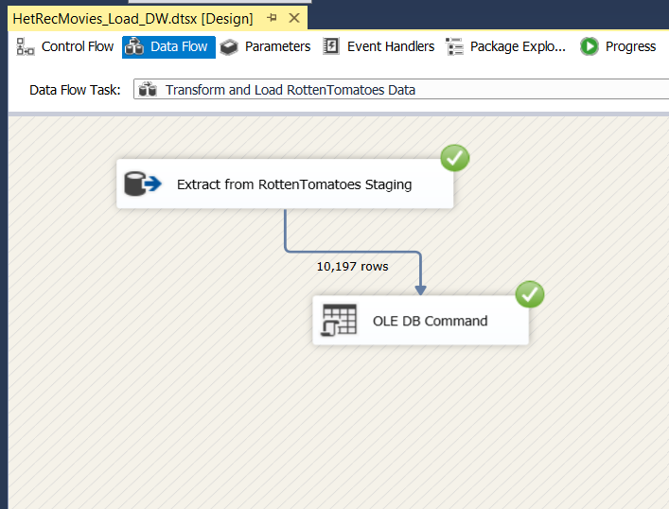

First, I have created a procedure called **UpdateDimRottenTomatoes** and executed in the

HetRecMovies_DW database.

OLE DB Command SSIS tool used to execute, **UpdateDimRottenTomatoes procedure**, it is used to insert data into rotten tomatoes staging to DimRottenTomatoes without data duplication.

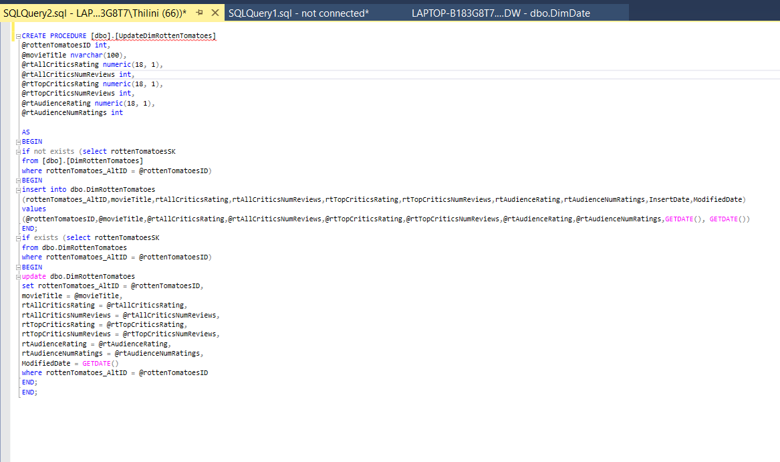

Then I did same process to Movies table and MovieGenres table as well.

**Transform and Movie Data**

Movies table and movie locations table primary key is movieID therefore**,** I created **DimMovies** dimension table by connecting Movies_Staging and MovieLocations_Staging.

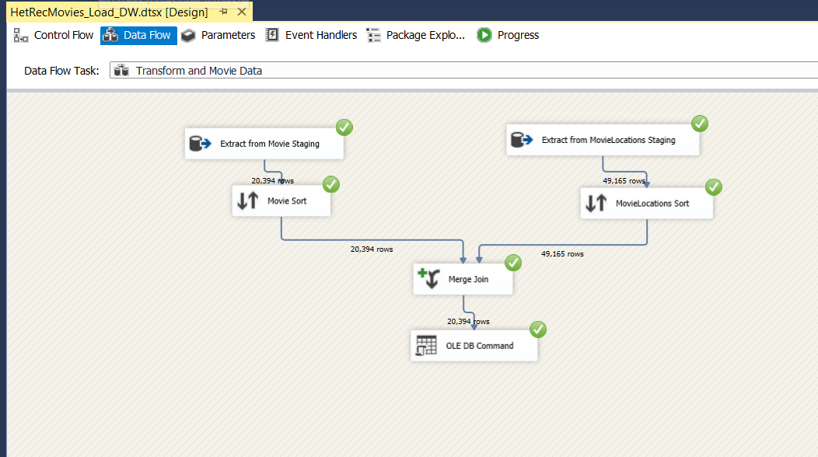

**UpdateDimMovies Procedure**

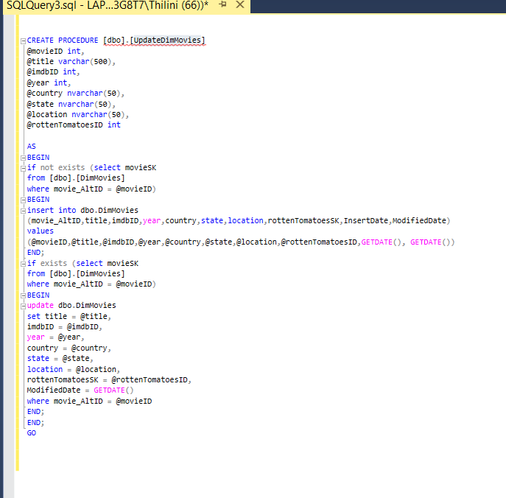

**Transform and Load MovieGenres Data**

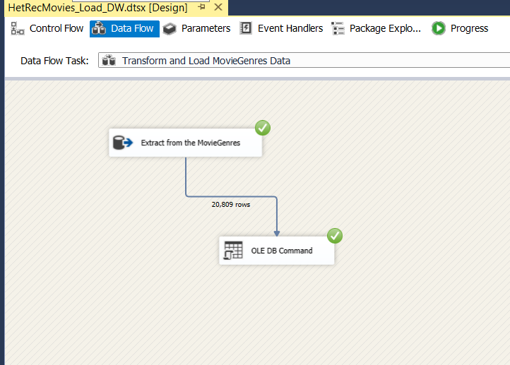

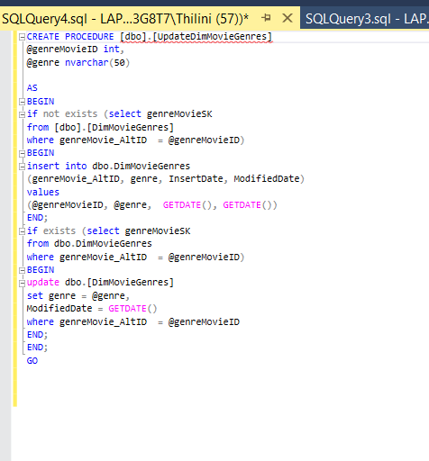**UpdateDimMovieGenres Procedure**

**Transform and Load MovieActors Data (Slowly Changing Dimension)**

I created Movie Actors Data Transformation by below mentioned steps.

• Created new package called HetRecMovies_Load_DW.dtsx.

• Then dragged and dropped a Data Flow Task, renamed it as Transform and Load Movie Actors data details and go the Data Flow tab.

• Dragged and dropped OLE DB Source, renamed as Extract from Movie Actors Staging

and configure it to access the Movie Actors Staging table.

• After that I dragged and dropped Slowly Changing Dimension movie actors and connect the OLE DB source

• In the SCD Configuration Wizard I set the configurations as below.

Once all configurations are done properly, it will automatically create the slowly changing dimension as shown below.

**Transform and Load FactUserRatedMovies Data**

**STEP 06: ETL Development -Accumulating Fact Table**

First, I extended my fact table (FactUserRatedMovies Table) with following 03 columns.

accm_txn_create_time

accm_txn_complete_time

txn_process_time_hours

Then I prepared a dataset which contains fact table natural key(userID) and accm_txn_complete time.

After that, I generated a new ETL SSIS package called accumulative_factTable.dtsx. Which receives data from this file and updates the accm txn complete time in my DW Fact table accordingly.

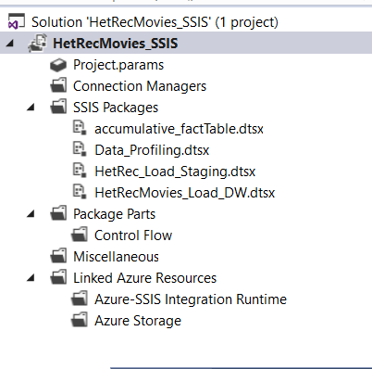

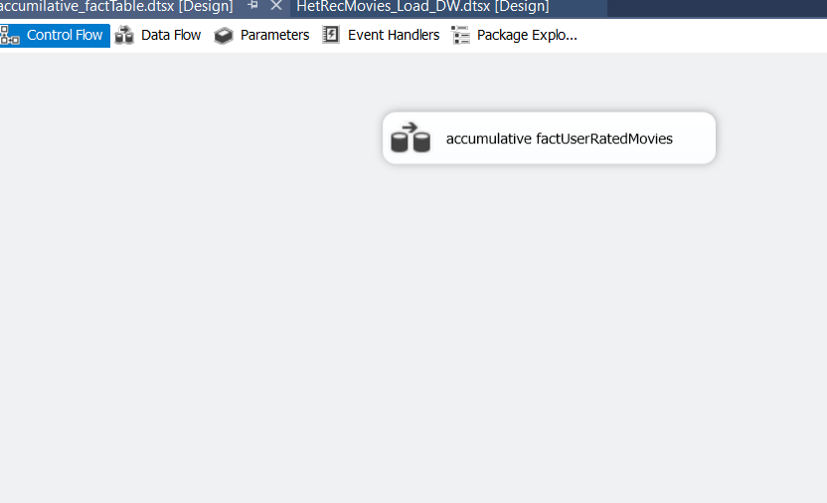

**Flat File Source**

**OLE DB Source**

**Sort with FactUserRatedMovies natural key. (userID)**

**Merge Join**

**Final FactUserRatedMovies Table with Updated txn_process_time.**

**Final HetRecMovies_Load_DW Control Flow.**

